FP03 file 16
Calcaneus bump
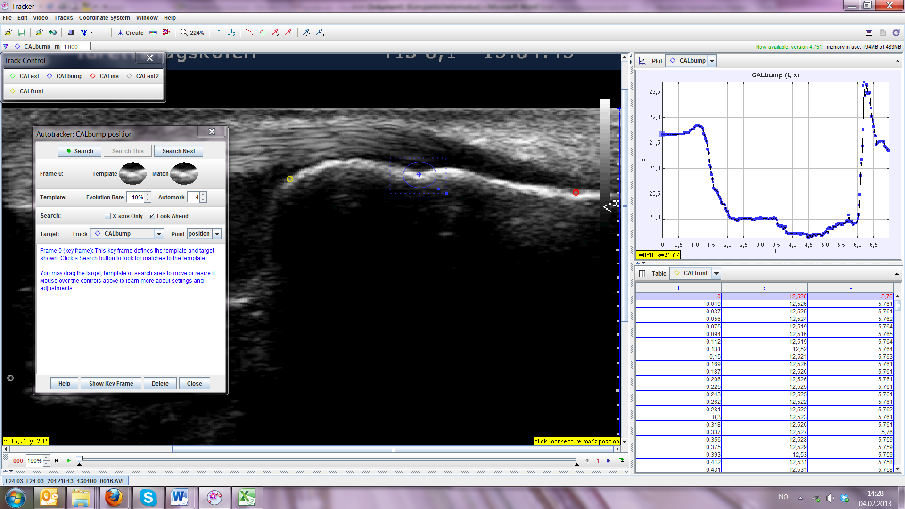
(seems to produce a displacement at 1,0-1,3 sec, not real?)

Calcaneus insertion
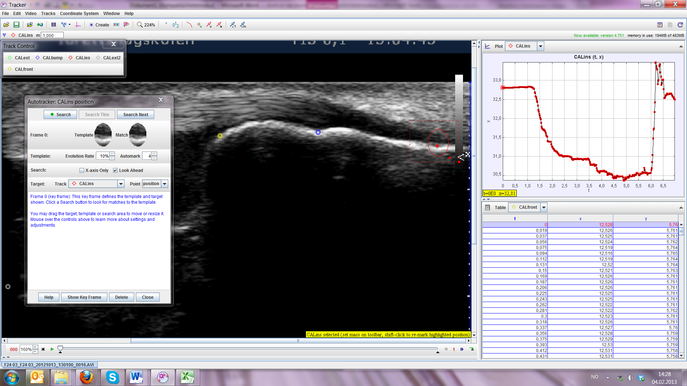
Calcaneus front
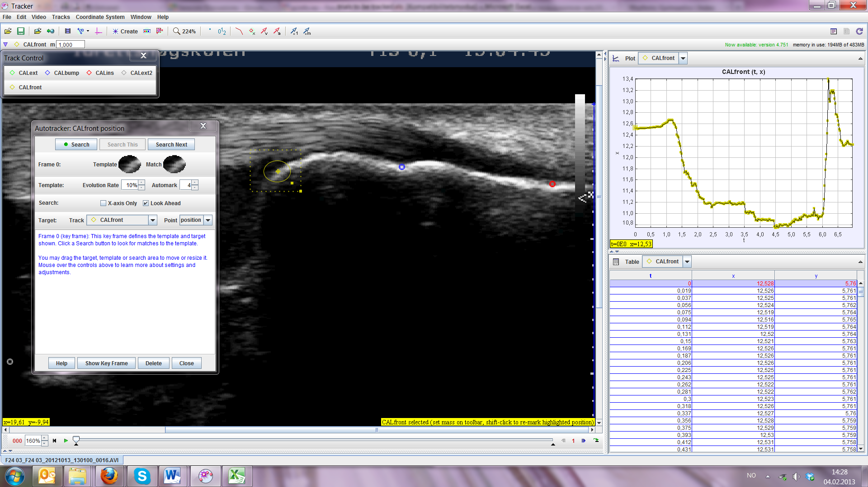
(seems to produce a displacement at 1,0-1,3 sec, not real?)

FP05 file 55
Calcaneus bump
Probably not an ideal point to track in this case
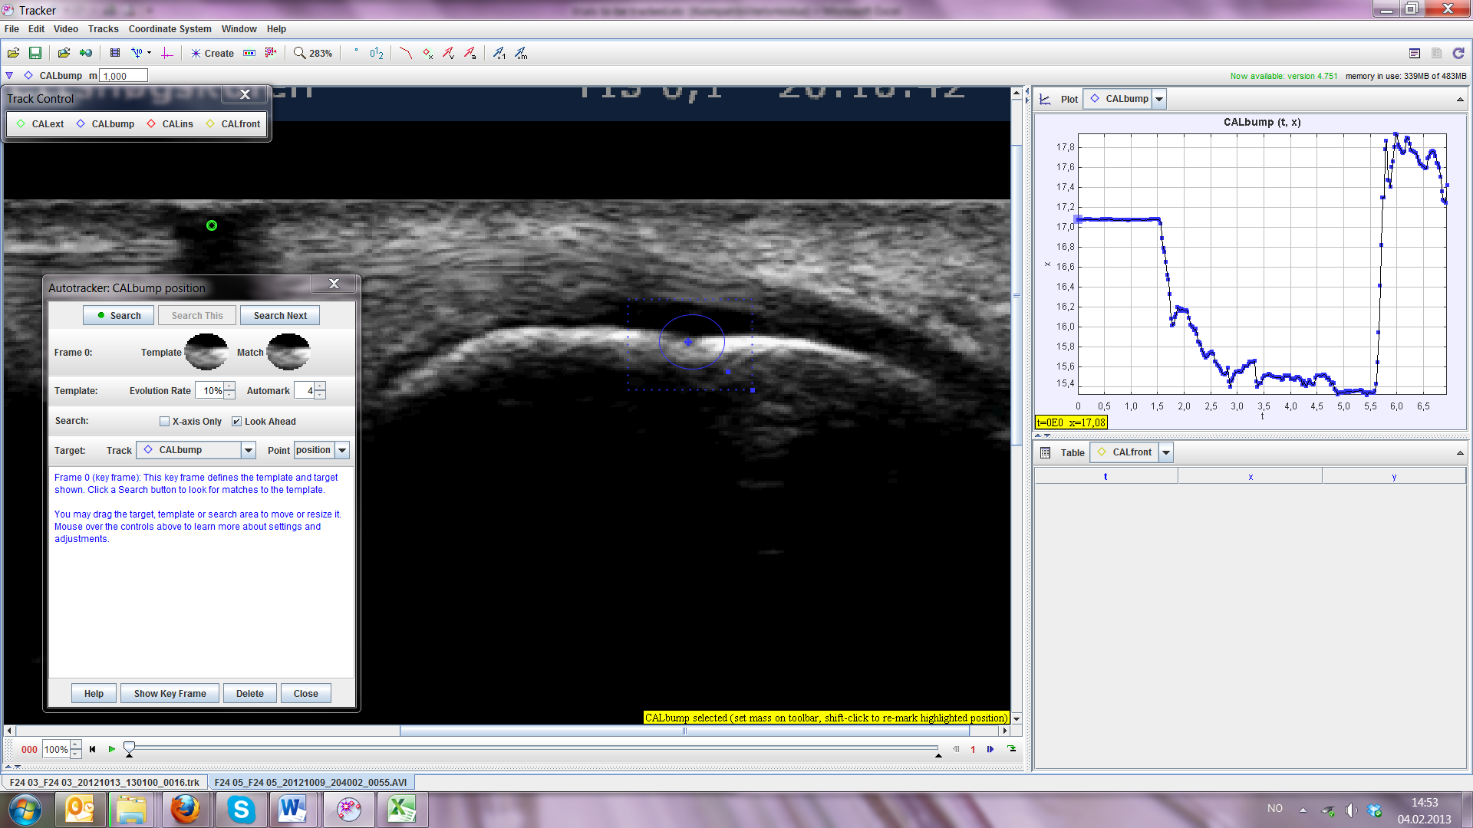
New key frame from #104
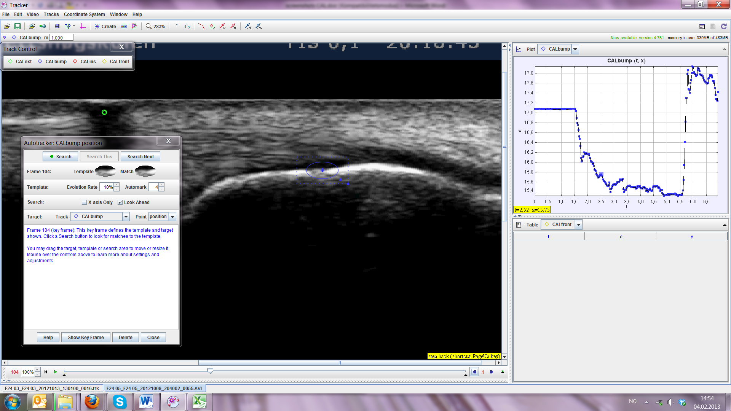
New key frame from #133
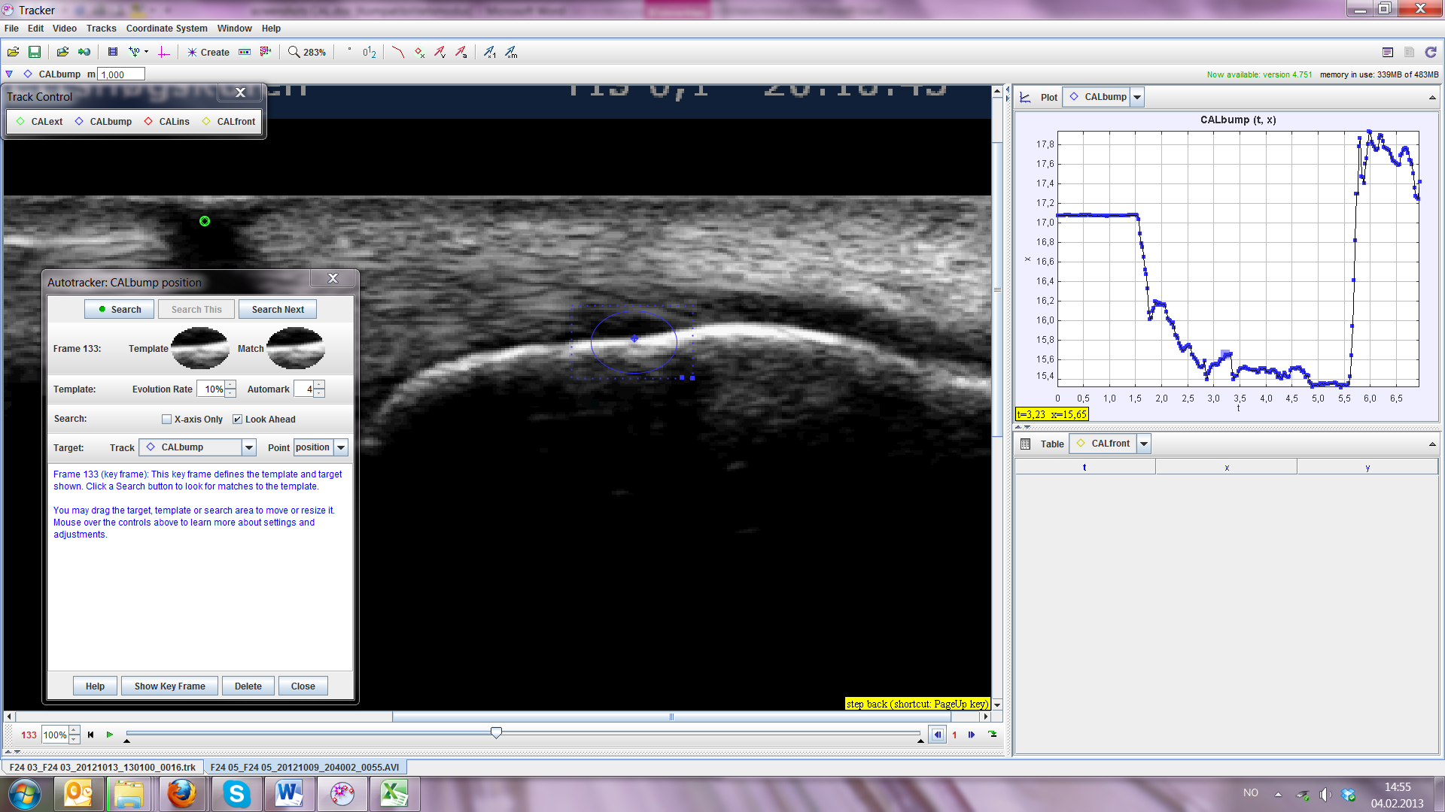
New key frame from #161
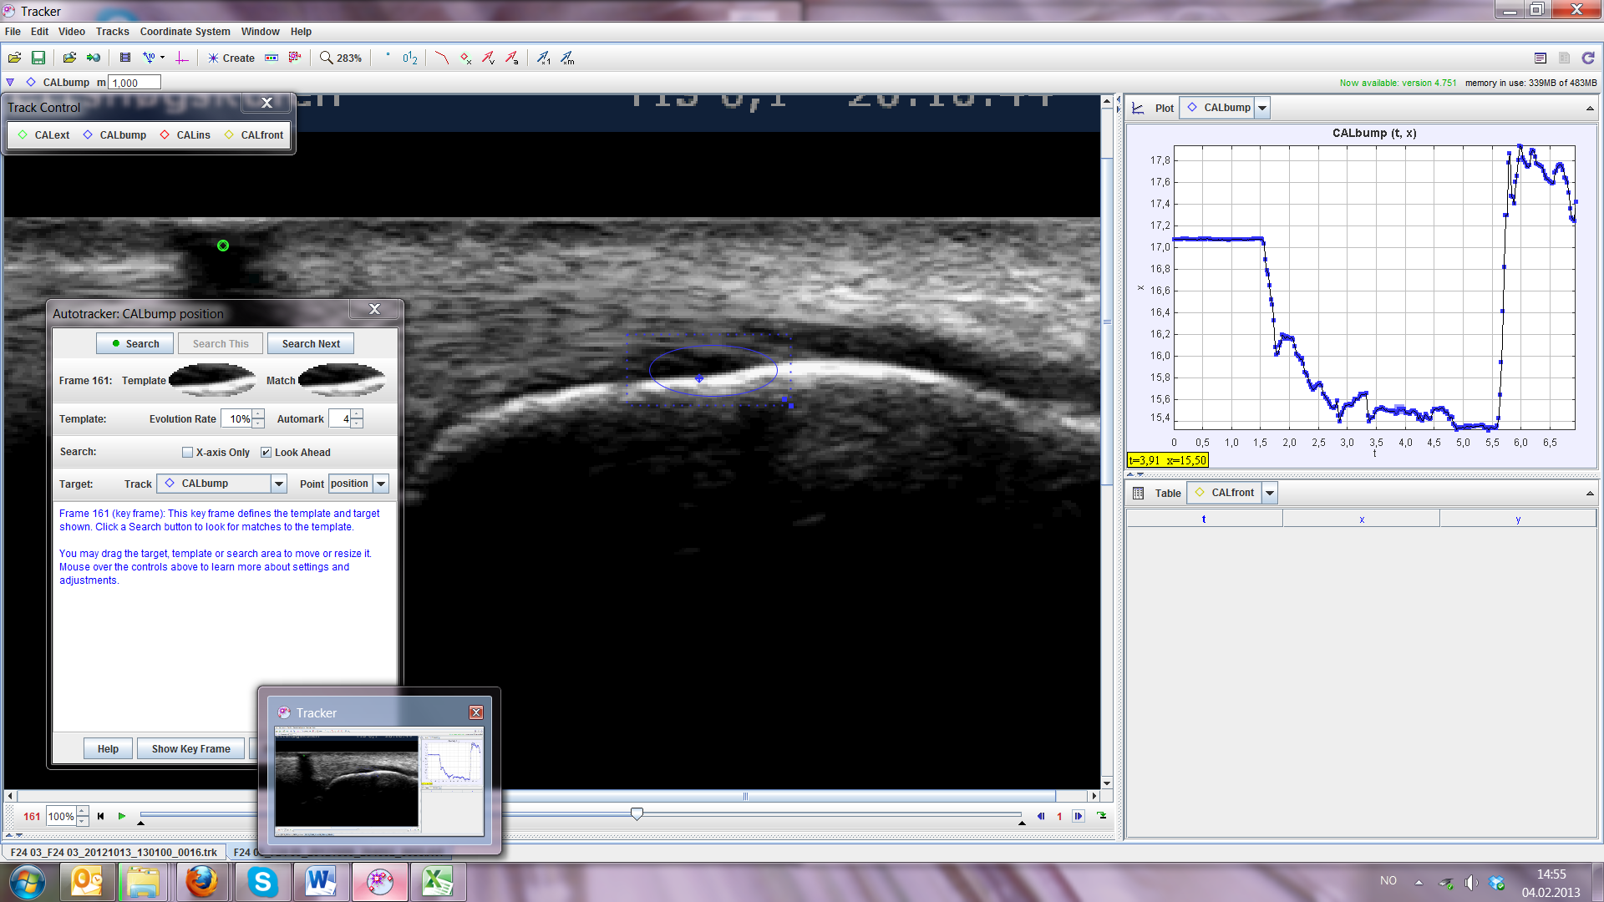

Calcaneus insertion
Not ideal
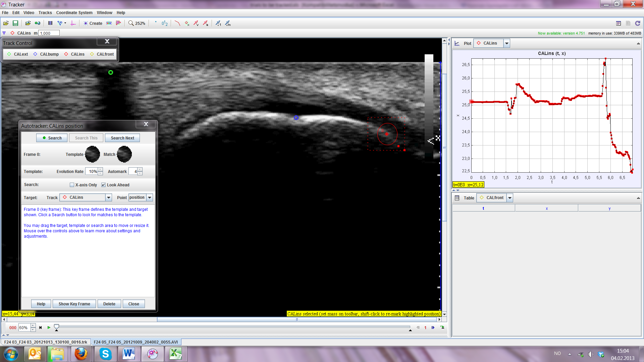

Calcaneus front
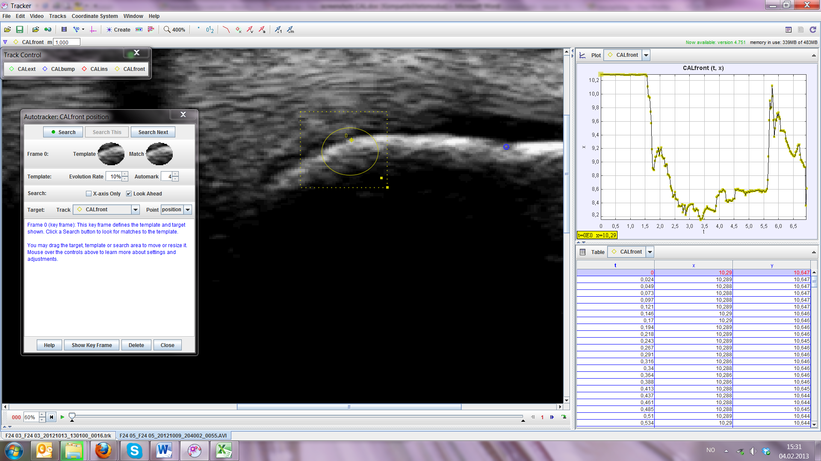
New key frame from #71
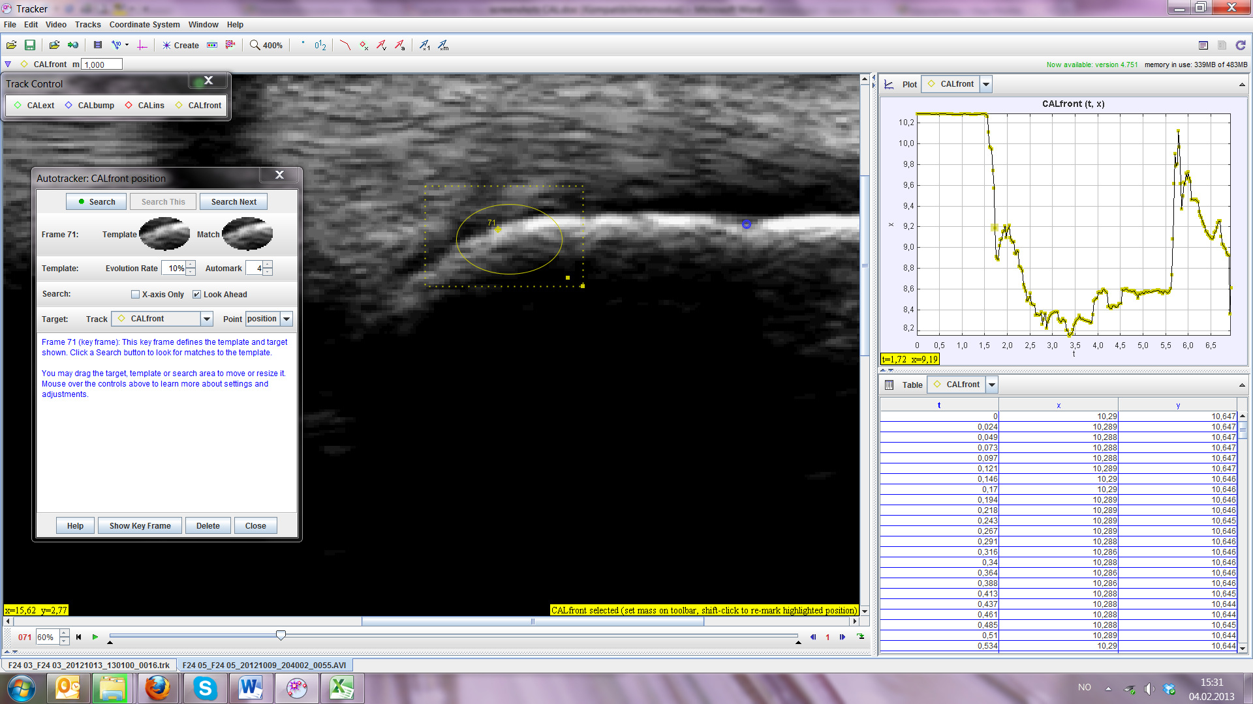

Still jumping around after 71, need to redo

